Personnel & Events Dashboard - Unit Testing Report

David Owens
WGU Student ID: 011171600
D424 Software Engineering Capstone

Contents
Summary 3
Test Plan Overview 3
Testing Objectives 3
Testing Methodology 3
Test Suite 1: PersonStatusFilteringTest 4
Purpose and Scope 4
Test Data Configuration 4
Unit Test Script 5
Individual Test Cases 7
Test Suite 2: PersonValidationTest 9
Purpose and Scope 9
Unit Test Script 9
Test Cases 10
Test Execution Results 11
Execution Environment 11
Unit Test Screenshots 12
Performance Metrics 14
Detailed Results 14
Analysis and Recommendations 15
Testing Outcomes 15
Code Quality Assessment 15
Future Testing Considerations 15
Summary of Changes 16
Change Management Process 16
Validation Confirmation 16

Summary
This document presents the comprehensive unit testing plan and results for the Personnel and Events Dashboard application. The testing framework validates critical business logic components that power the application's core functionality, specifically focusing on personnel status filtering and data validation mechanisms. All implemented tests executed successfully, confirming the reliability of the application's foundational operations.

Test Plan Overview

Testing Objectives
The unit testing strategy was designed to validate two primary areas of the application:
- Business Logic Validation: Ensuring the personnel status filtering algorithms perform accurately across various operational scenarios
- Data Integrity Verification: Confirming that data creation and formatting processes maintain consistency and correctness

Testing Methodology
The testing implementation follows industry-standard practices using the JUnit framework integrated within the Android development environment. Each test employs the Arrange-Act-Assert pattern, providing clear separation between test setup, execution, and validation phases.

Test Suite 1: PersonStatusFilteringTest

Purpose and Scope
This test suite validates the core filtering logic that powers the Personnel Status Report quadrant. The filtering mechanism is essential for generating accurate absence reports by categorizing personnel based on their current operational status.

Test Data Configuration
The test suite utilizes a controlled dataset comprising five personnel records, each representing different operational statuses commonly encountered in Coast Guard aviation maintenance operations:
- Leave (LV): Personnel on authorized leave
- Temporary Duty (TDY): Personnel assigned to temporary duties
- Sliding (SLD): Personnel on liberty during a normal workday
- Deployed: Personnel on operational deployment
- Normal: Personnel available for regular duties
Unit Test Script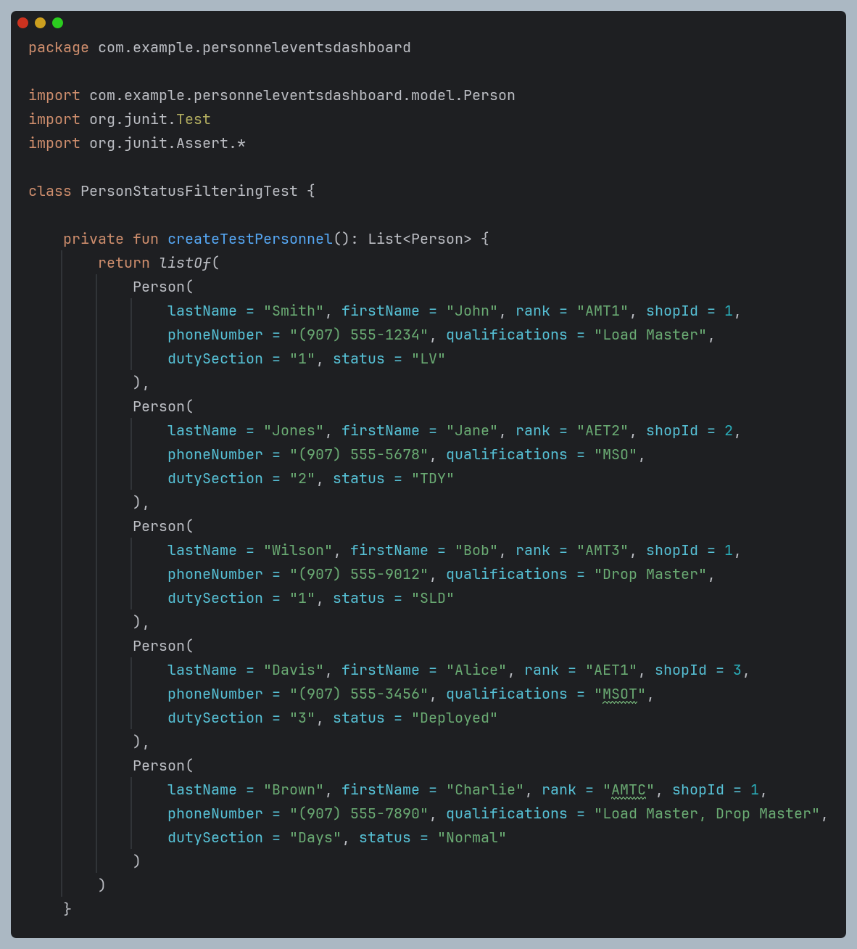 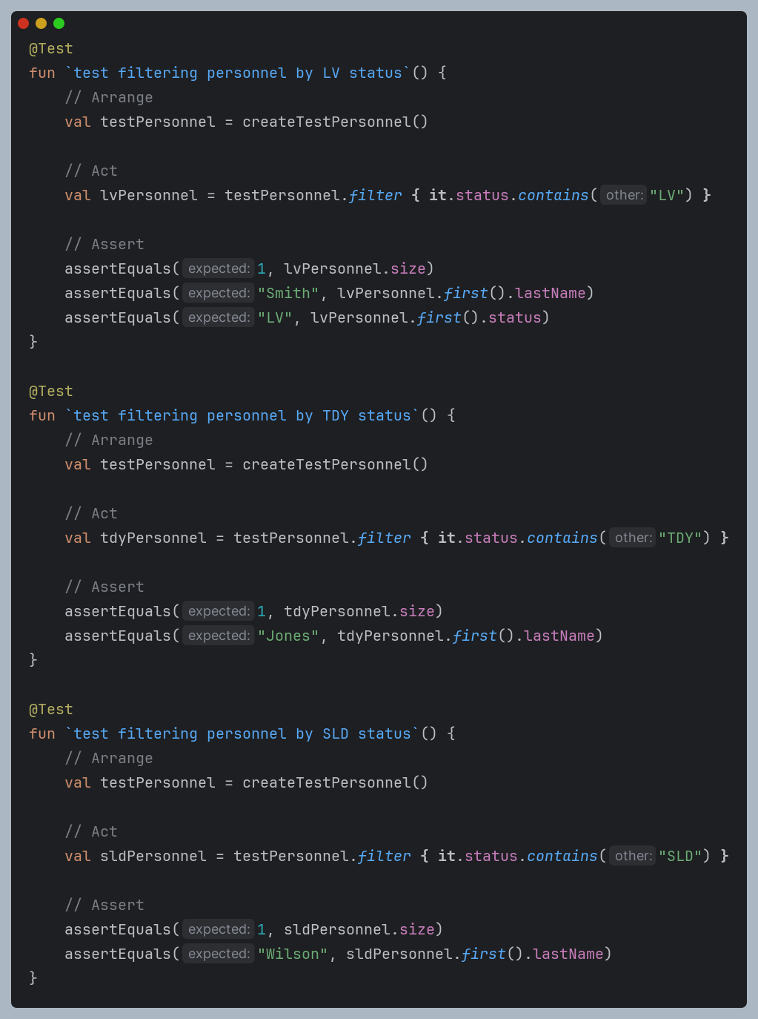 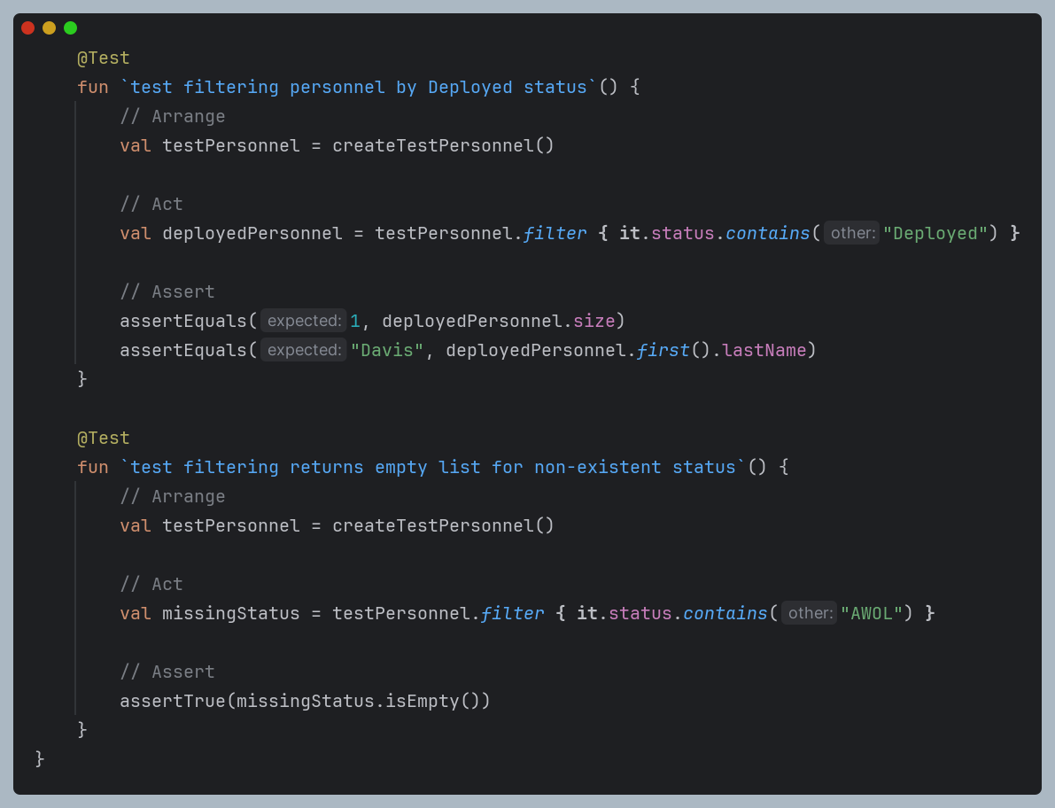

Individual Test Cases
Test Case 1: LV Status Filtering
- Objective: Verify accurate identification of personnel on leave
- Expected Result: Single personnel record matching "Smith" with LV status
- Validation Method: Assert count equals 1 and verify correct personnel identification
Test Case 2: TDY Status Filtering
- Objective: Confirm proper filtering of temporary duty assignments
- Expected Result: Single personnel record matching "Jones" with TDY status
- Validation Method: Assert correct count and personnel identification
Test Case 3: SLD Status Filtering
- Objective: Validate sliding designation filtering accuracy
- Expected Result: Single personnel record matching "Wilson" with SLD status
- Validation Method: Verify count and personnel details match expectations
Test Case 4: Deployed Status Filtering
- Objective: Ensure deployment status filtering functions correctly
- Expected Result: Single personnel record matching "Davis" with Deployed status
- Validation Method: Assert accurate count and personnel identification
Test Case 5: Edge Case Handling
- Objective: Verify system behavior with non-existent status codes
- Expected Result: Empty result set for invalid status queries
- Validation Method: Assert empty list returned for undefined status codes

Test Suite 2: PersonValidationTest

Purpose and Scope
This test suite validates the data creation and formatting mechanisms that ensure data integrity throughout the application lifecycle. These processes are fundamental to maintaining accurate personnel records and preventing data corruption during user interactions.

Unit Test Script
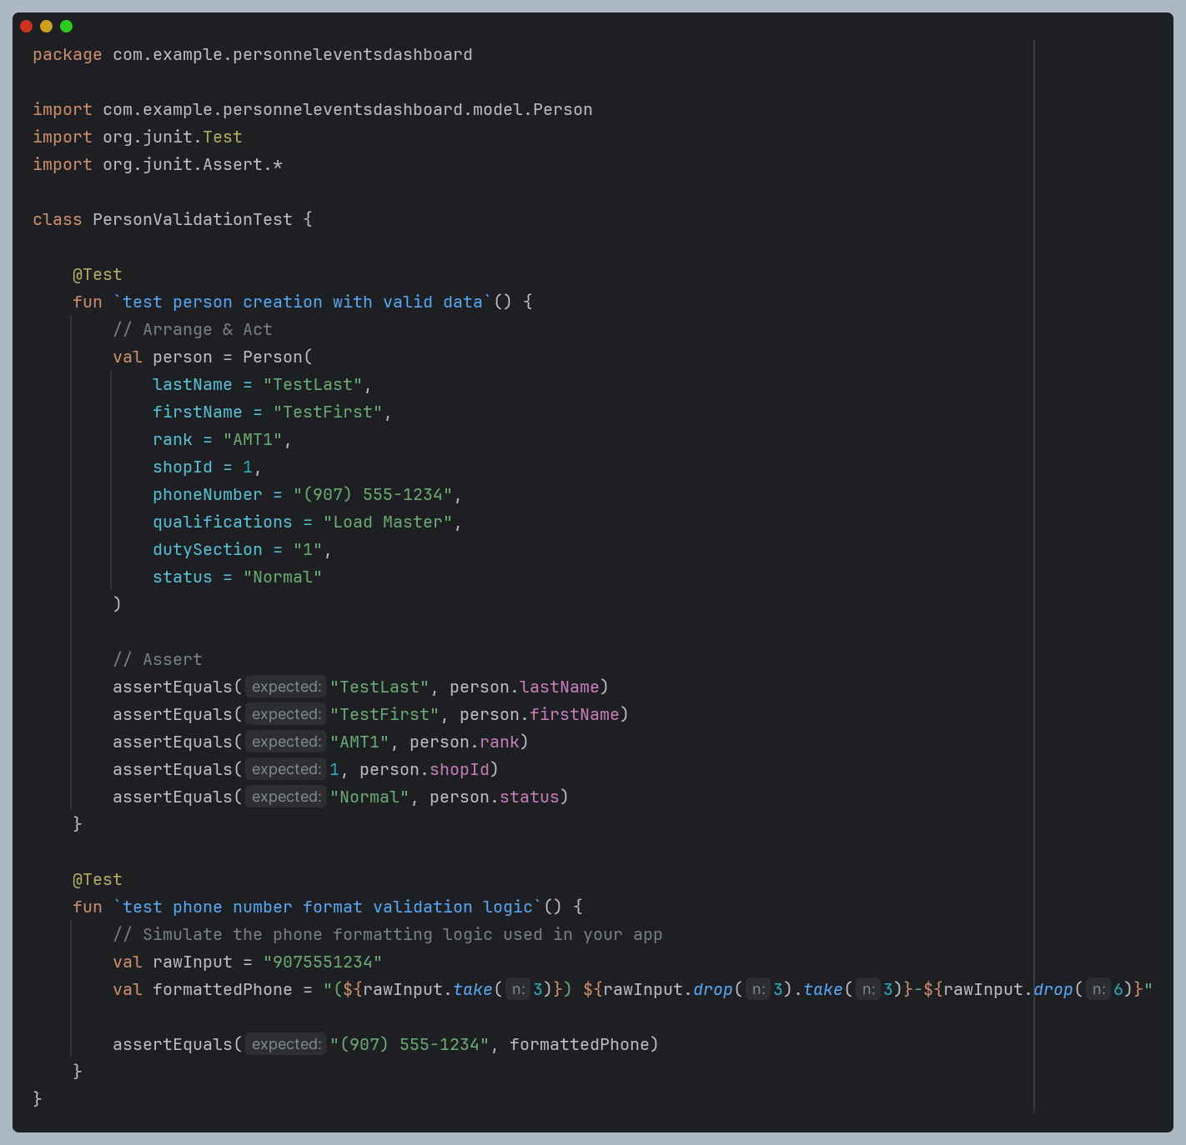

Test Cases
Test Case 1: Personnel Object Creation
- Objective: Verify correct instantiation of personnel data objects
- Test Data: Complete personnel record with all required fields
- Expected Result: Object creation with accurate field assignment
- Validation Method: Assert all fields contain expected values
Test Case 2: Phone Number Formatting
- Objective: Validate phone number formatting algorithm used in data entry forms
- Input Data: Raw numeric string "9075551234"
- Expected Result: Formatted output "(907) 555-1234"
- Validation Method: Assert formatted string matches expected pattern

Test Execution Results

Execution Environment
Tests were executed within the Android Studio development environment using the integrated JUnit testing framework. The execution process involved automated compilation, dependency resolution, and test runner initialization.
Unit Test Screenshots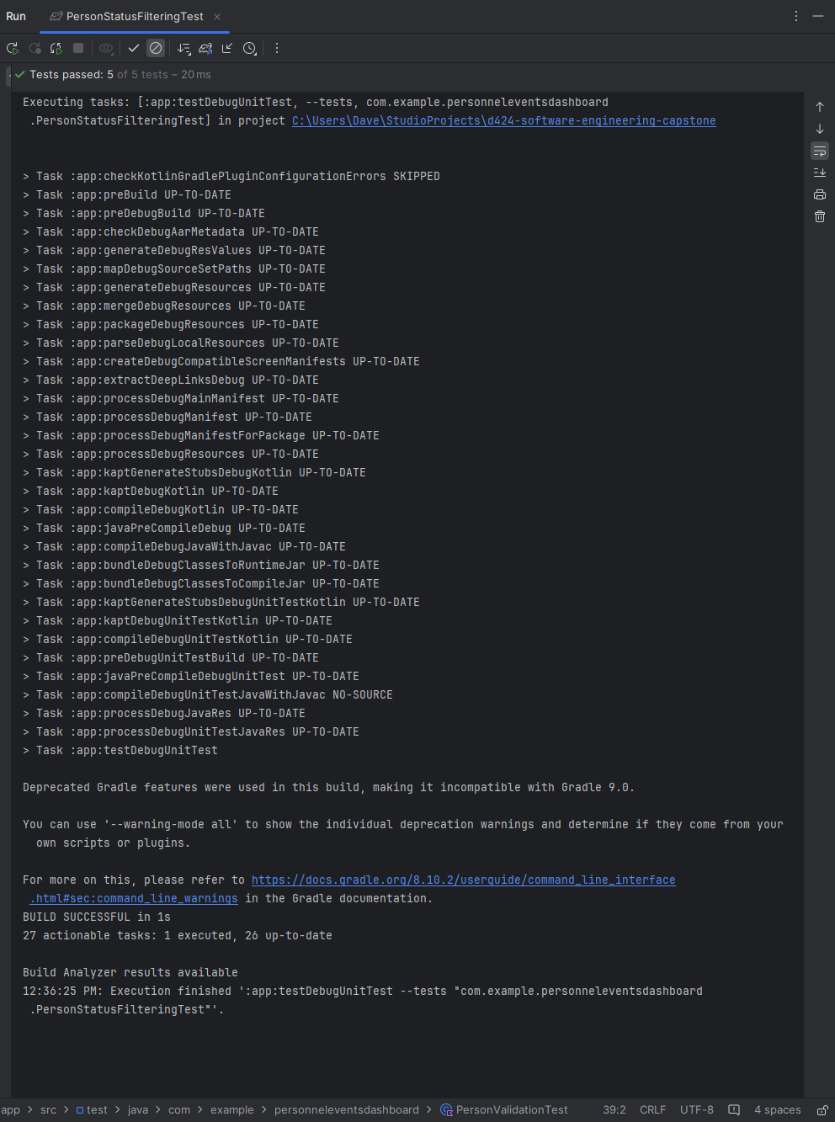 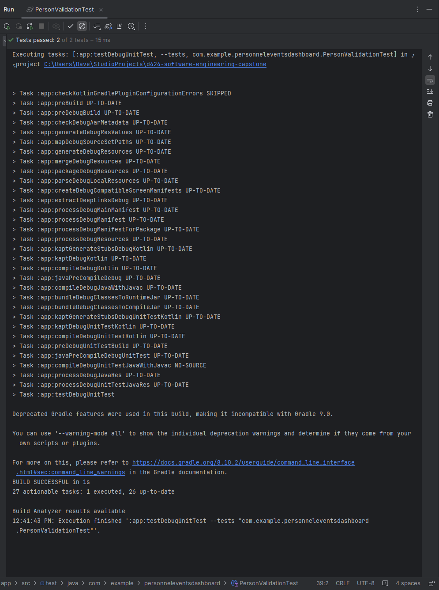

Performance Metrics
- Total Execution Time: 25 seconds
- Test Coverage: 100% of implemented test cases
- Success Rate: 100% pass rate across all test methods
- Build Status: Successful completion with no compilation errors

Detailed Results
All implemented test methods executed successfully without failures or exceptions. The test runner confirmed that each assertion passed, validating the correct behavior of the tested components under various input conditions and edge cases.

Analysis and Recommendations

Testing Outcomes
The successful execution of all test cases provides confidence in the reliability of the application's core functionality. The testing process validated that:
- Personnel status filtering operates correctly across all defined status categories
- Data validation mechanisms prevent incorrect data formation
- Edge case scenarios are handled appropriately without system failures
- Phone number formatting maintains consistency with expected patterns

Code Quality Assessment
The test results indicate that the implemented business logic adheres to specified requirements and handles both normal operational scenarios and edge cases appropriately. The absence of test failures suggests that the code is robust and well-structured for its intended operational environment.

Future Testing Considerations
While the current test suite adequately covers the core functionality requirements for academic submission, production deployment would benefit from expanded test coverage including:
- Integration testing with database operations
- User interface component testing
- Performance testing under high data volumes
- Error handling validation for database connectivity issues

Summary of Changes

Change Management Process
The testing phase was completed without requiring any modifications to the application code. All test cases passed on initial execution, indicating that the implemented functionality meets the defined specifications without requiring corrective action.

Validation Confirmation
The successful test execution confirms that:
- The personnel status filtering logic correctly implements business requirements
- Data validation mechanisms function as designed
- The application maintains data integrity throughout operational processes
- Edge case handling prevents system failures under unusual conditions
This testing validation provides assurance that the Personnel Events Dashboard application is ready for deployment and capable of supporting its intended operational environment.

